Account Payments with PayMyTuition

The NOSM University Self-Service portal in conjunction with PayMyTuition/MTFX payment solution is used for accessing student accounts and exchanging funds with NOSM University.

To access Self-Service, navigate to www.nosm.ca and click on the myNOSM link to expand the menu and then click on Self-Service from the Learners menu.

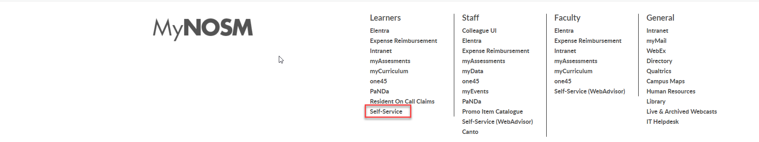
Login using your NOSM University credentials.

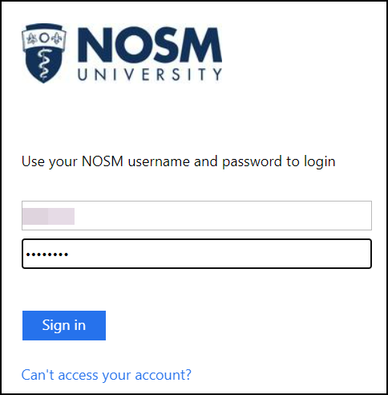

Once logged into Self-Service, from the Account Overview page you can click on Make a Payment.

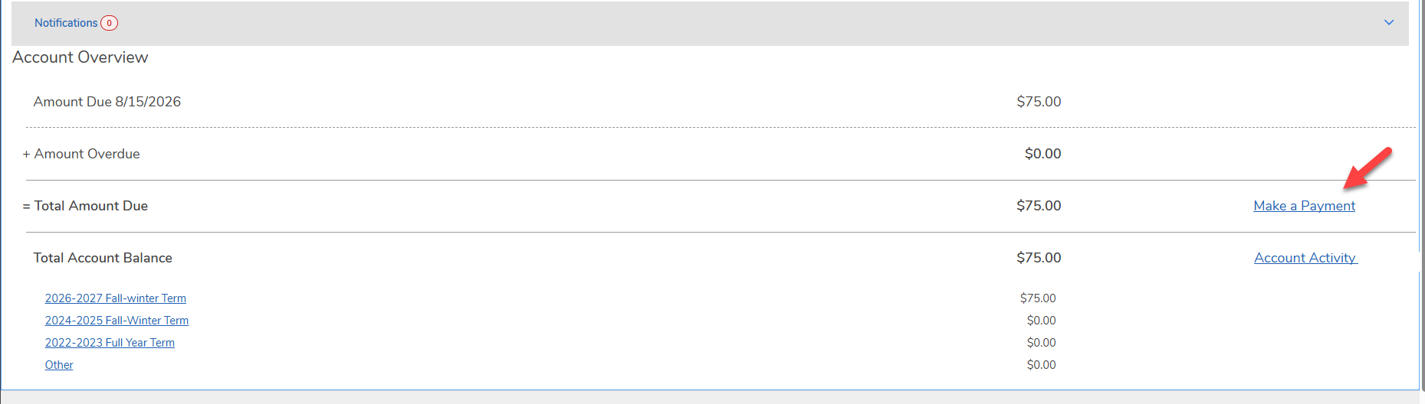

Alternatively, click on the left navigation panel and click on Learner Finance. Next, select Account Information to locate PayMyTuition.

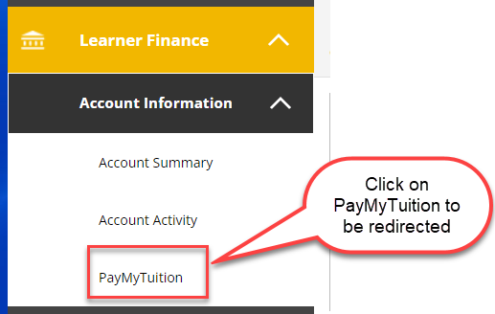

If you are not redirected to PayMyTuition, ensure you have disabled any popup blockers. Redirection can take several seconds.

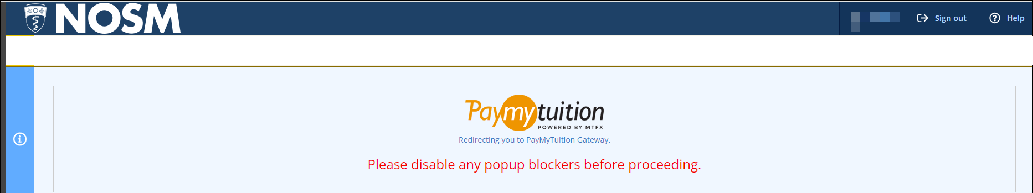

Once you have been redirected to the PayMyTuition portal, you will arrive at the screen below. Click on the “Make a Payment” button to initiate your payment.

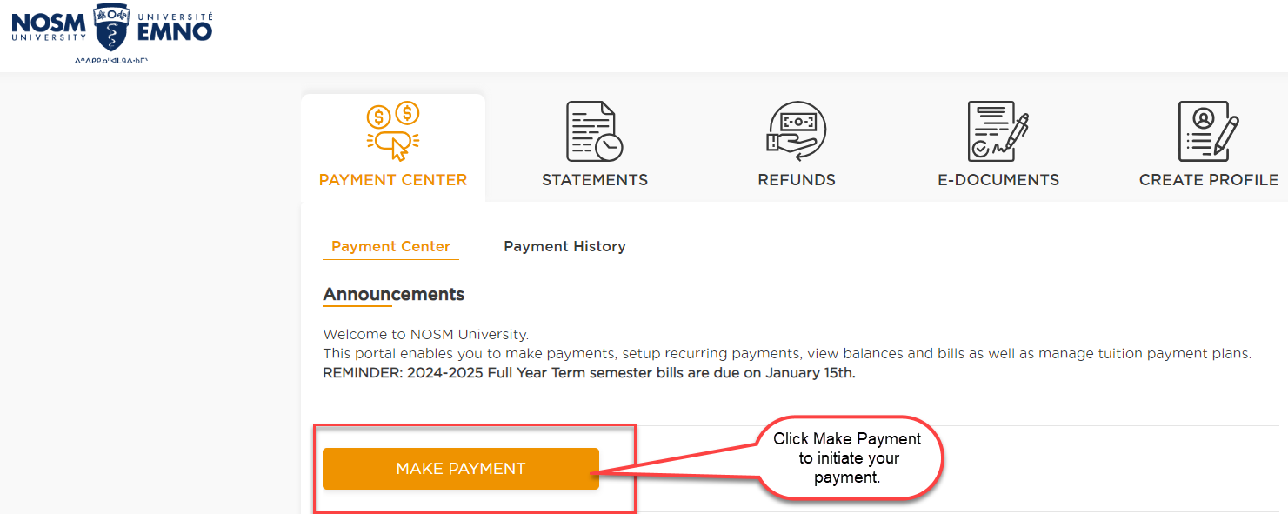

From the next screen, click on the Pay Now button to see your charges and then check the term where you want to make a payment.

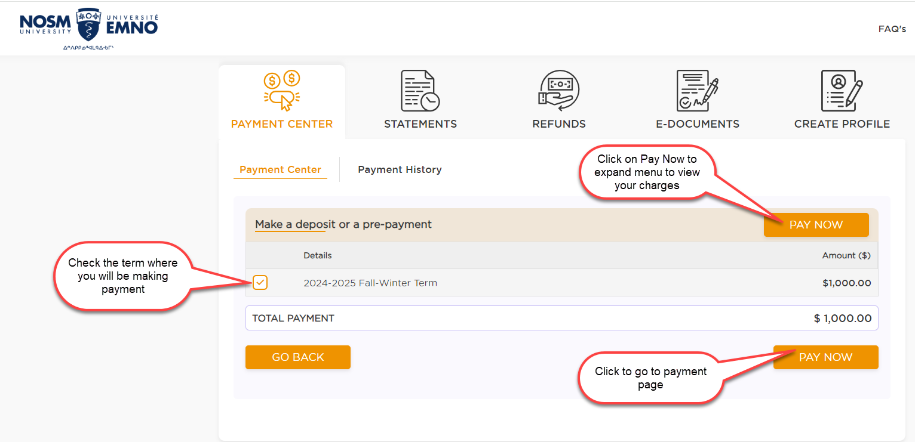

Choose your preferred payment method from the drop-down list.

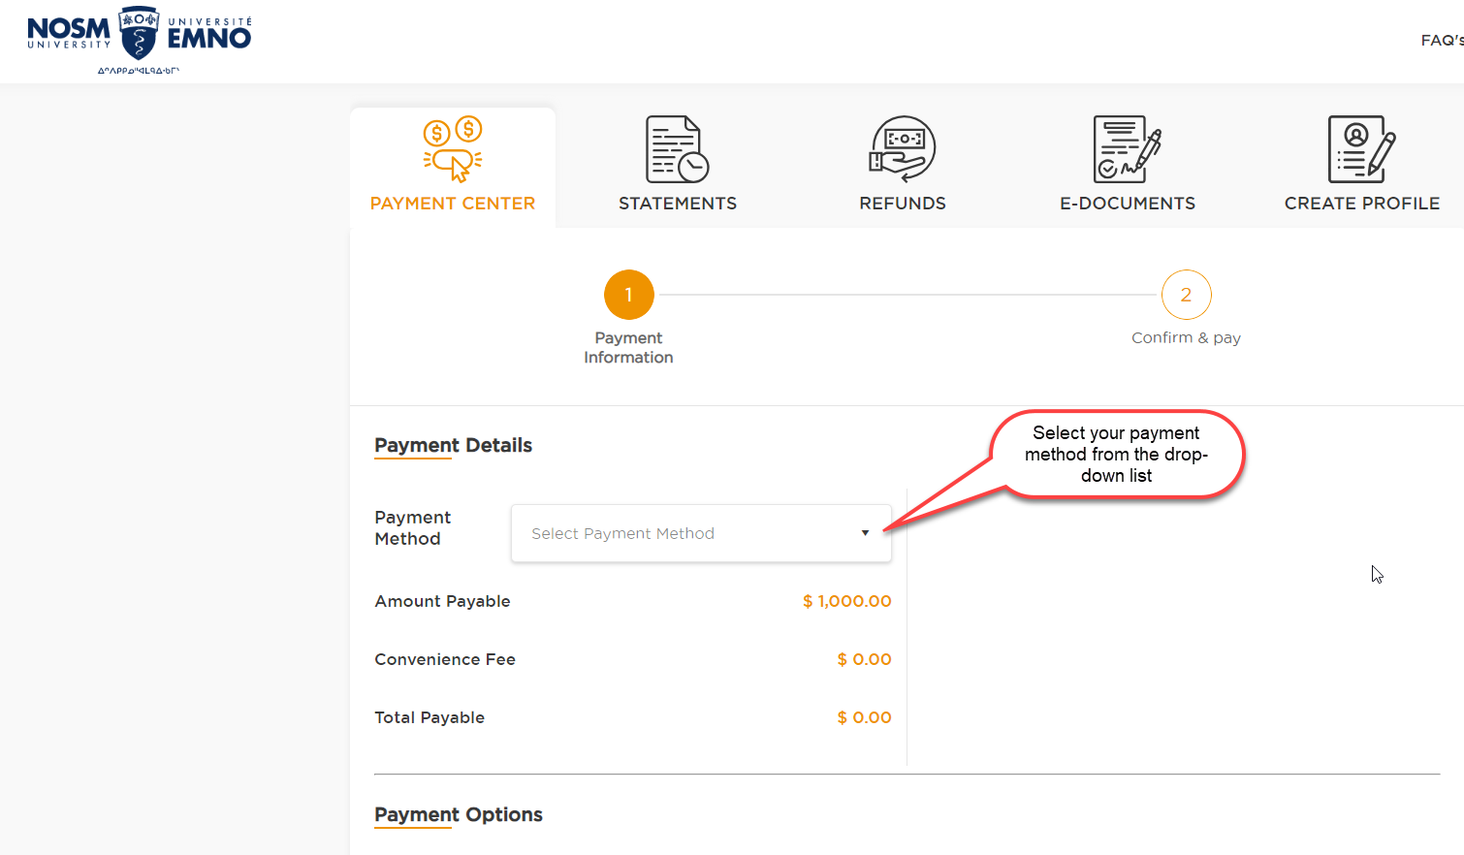

After choosing your payment method, click on the Next button.

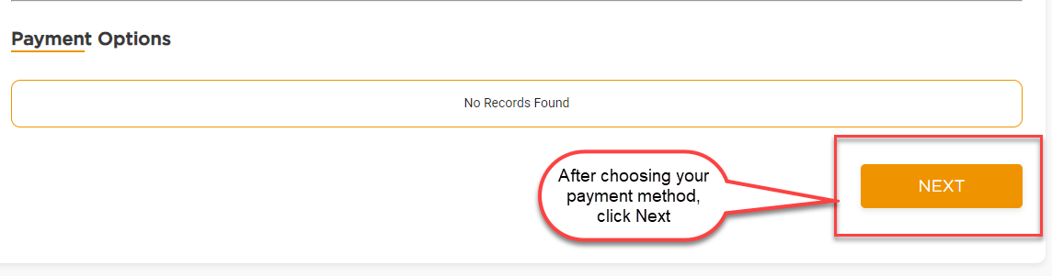

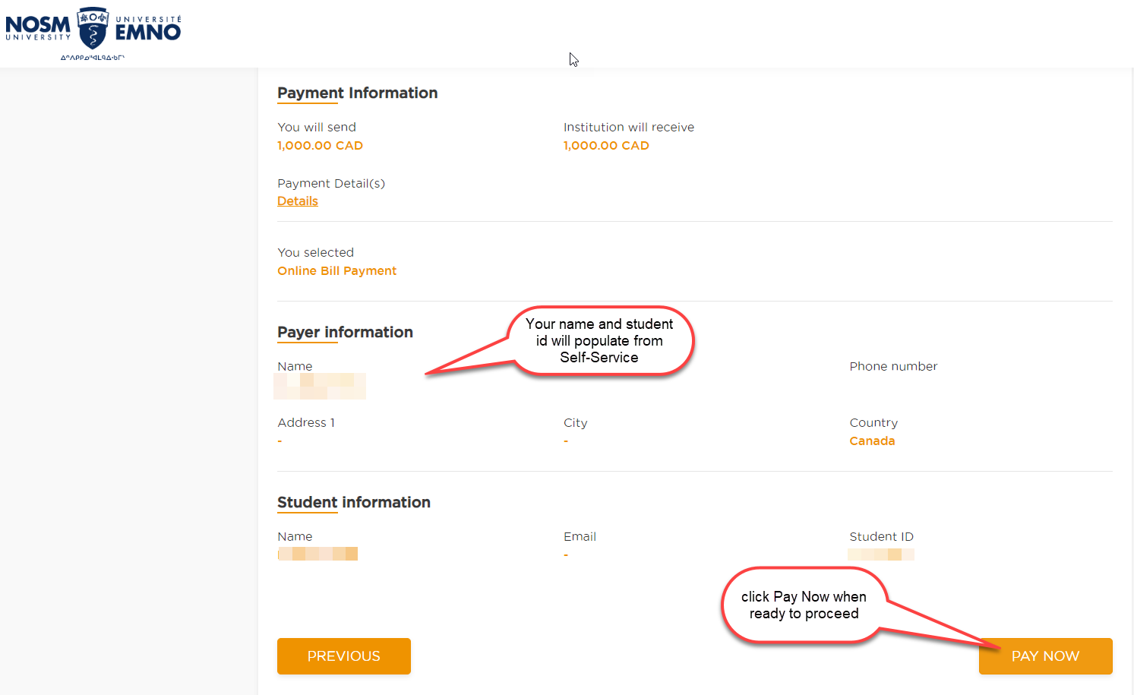
Your name and student id will populate from Self-Service. Click on Pay Now to proceed with finalizing payment.

Review the information on the summary page and proceed to PAY NOW.

For any payment types that require further instructions, click on the Download Instructions button.

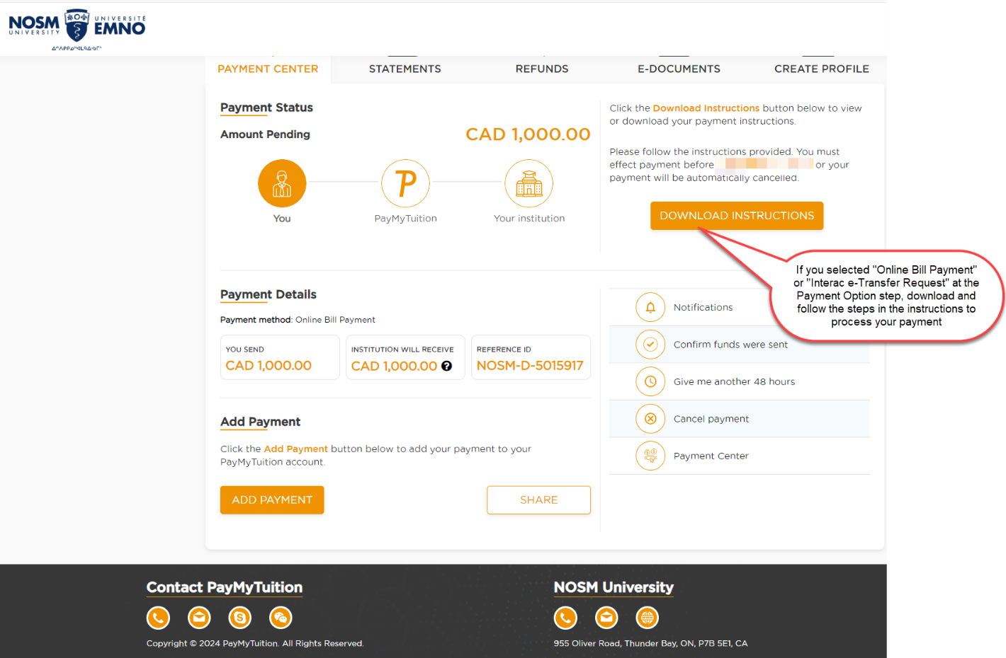
Your payment history can be viewed by clicking on Payment Center in the PayMyTuition portal.

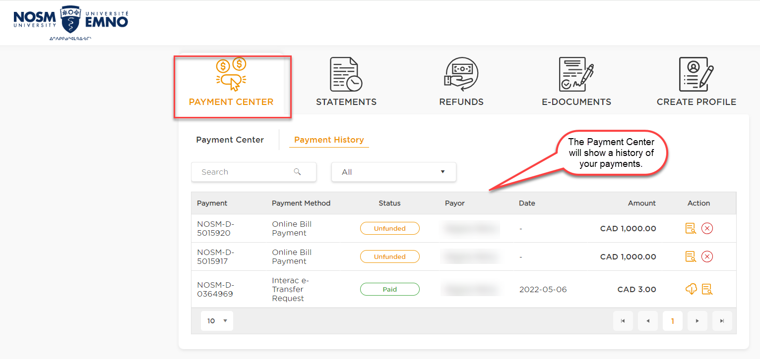

Additional Information on PayMyTuition:
Frequently Asked Questions

Need Assistance?
Connect with PayMyTuition directly by calling 1.855.663.6839 (toll-free) or through one of their local country contact numbers.

You can also reach PayMyTuition Support at support@paymytuition.com or through their support page.

PayMyTuition’s customer support team is available to you through live chat, email, and phone to answer any of your questions and help you with the payment process.

After your payment is processed, you can also view the details in your Self-Service account.

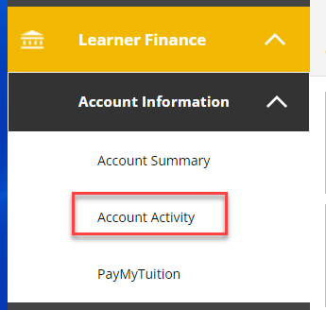

The details of your account activity will be displayed. You can also view or download a PDF statement.

