SHAREPOINT ACCESS GUIDE

- NAVIGATE TO NOSM UNIVERSITY WEBSITE
Open a new browser window, type nosm.ca into the URL address bar at the top and click enter.

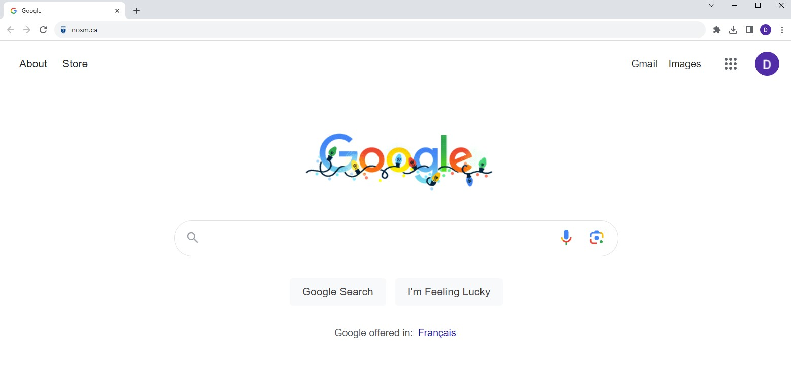

- NAVIGATE TO SHAREPOINT USING myNOSM U
SharePoint is available on the NOSM University main page, under the general links in myNOSM U.

  - Click on myNOSM U in the top right corner of the NOSM University main page.

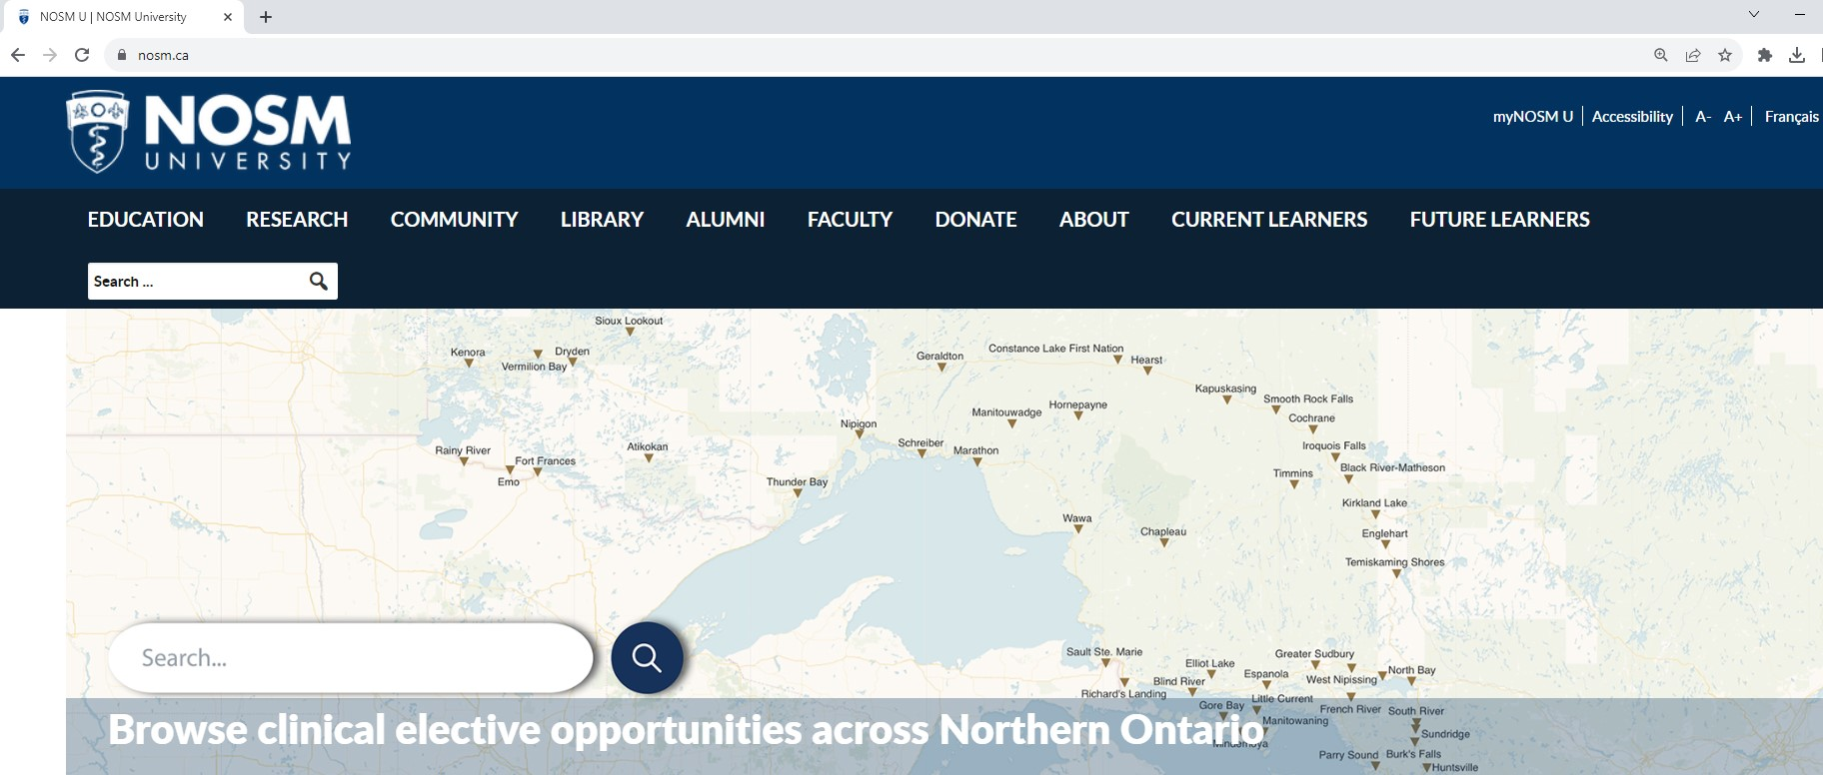

  - Click on Intranet from the General column.

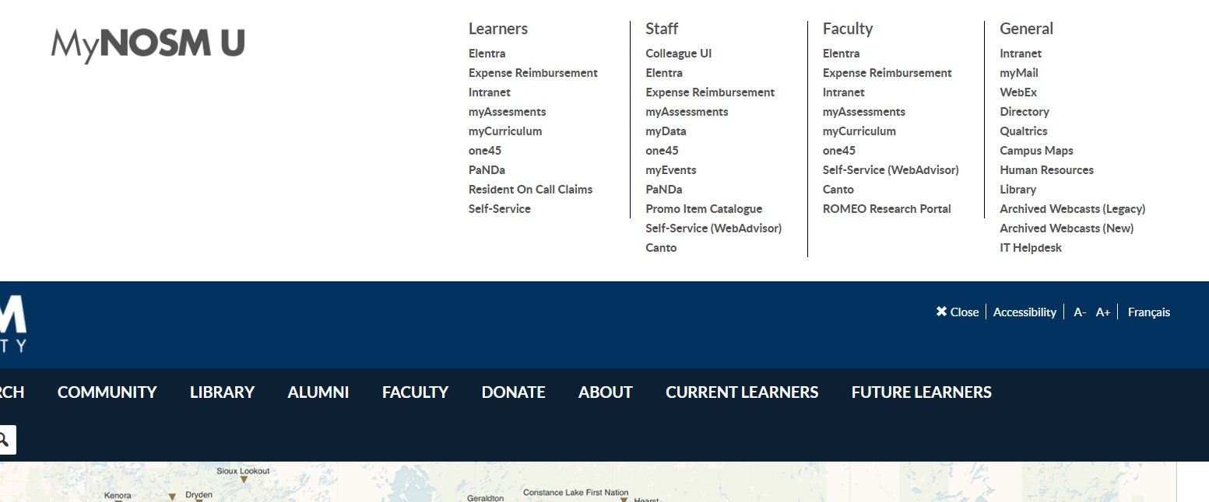

- LOGIN SCREEN FOR SHAREPOINT
Enter the username and password provided by the NOSM U IT Team and click on Sign In.

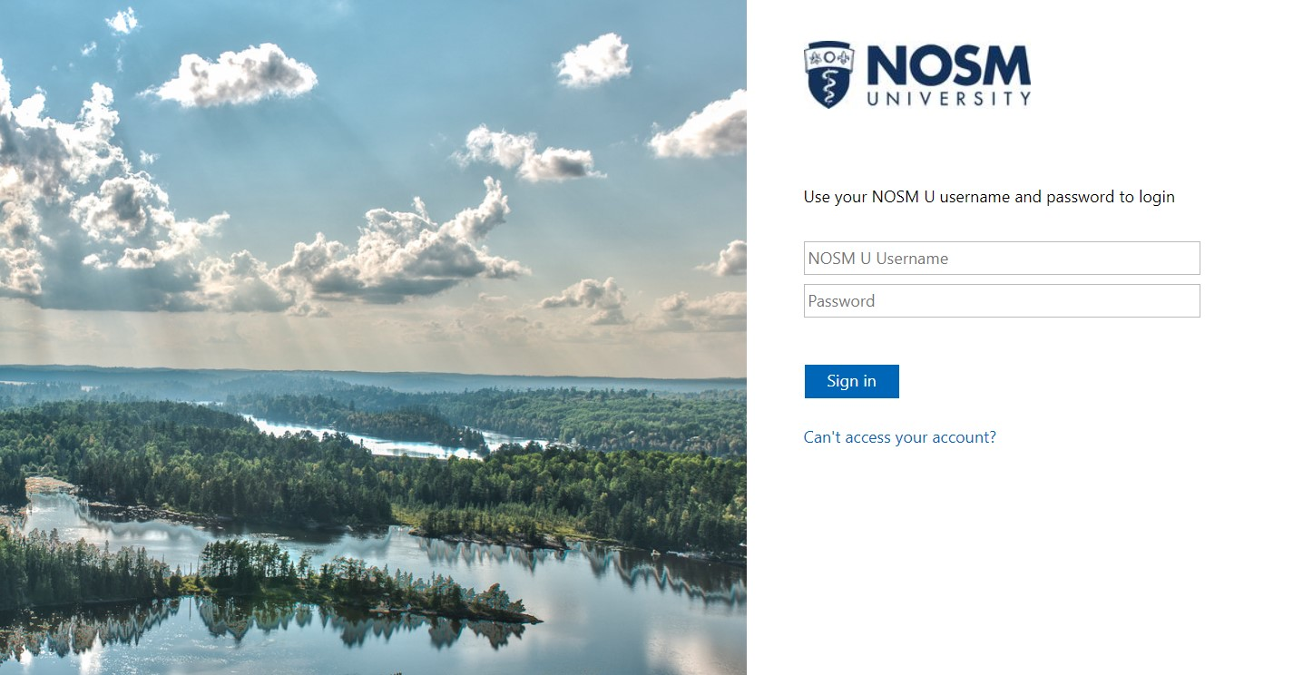

USEFUL TIP: to retrieve your NOSM U username or password, or if you need to reset your password, please contact the NOSM U IT Helpdesk, helpdesk@nosm.ca.
- NAVIGATE TO NODIP’S SHAREPOINT SITE

  - Type NODIP into the search bar at the top and click enter.

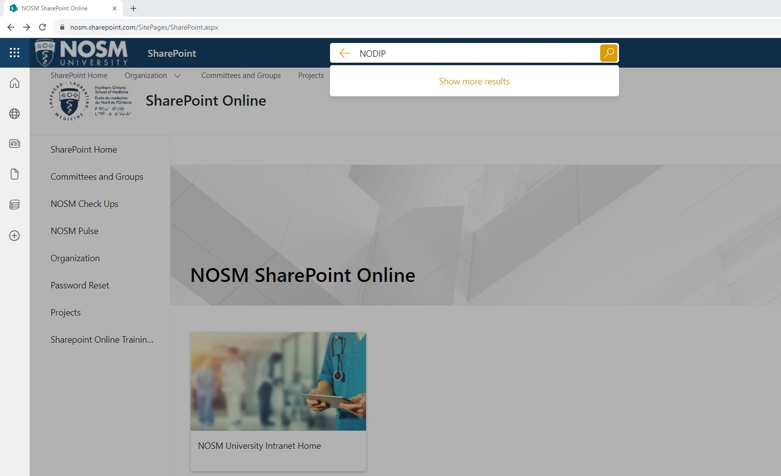

  - Click on the link for the NODIP Site option - https://nosm.sharepoint.com/sites/NODIP

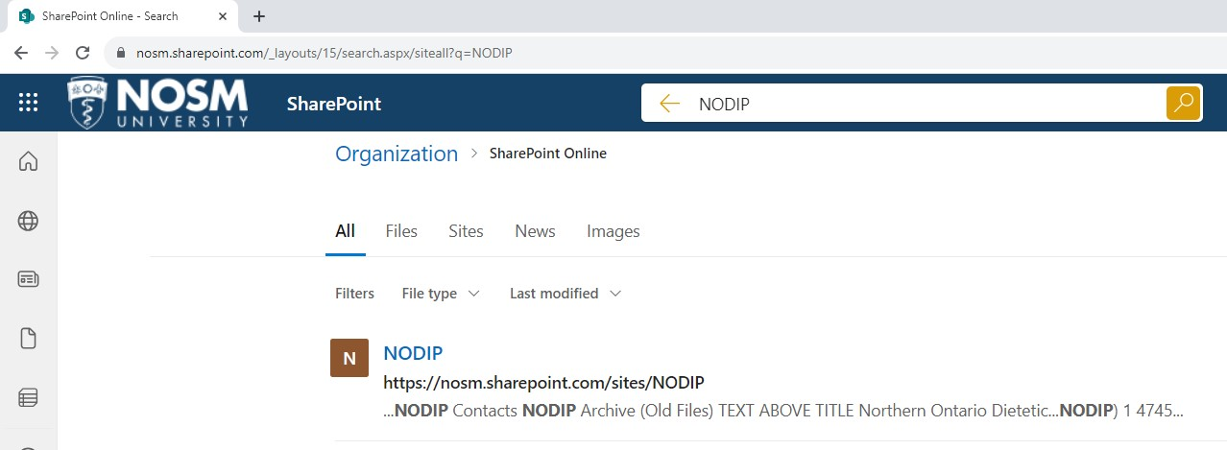

- NODIP SHAREPOINT SITE
The NODIP SharePoint site main page features six images representing sub-sections which contain specific resources. If you encounter any issues, please contact the NODIP Administrative Assistant nodip@nosm.ca.

