Needs Assessment Data Type | Source (e.g., link, title, description) | Summary of Information from source | Topics or learning objectives identified from this source | CanMEDS role(s) addressed by this topic/learning objective
Best Practice Guidelines
Chart Audits
Clinical Observances/ Patient Outcomes
Emerging Trends
Epidemiological/ Population Health Data
Evaluation Summary from Previous Program
Focus Groups/ Interviews
Other
Peer Reviewed Literature/ Research Findings
Physician/ Faculty/ Target Audience Request
Referral Patterns
Scientific Planning Committee Minutes
Survey of Anticipated Target Audience

 | 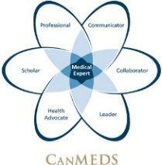  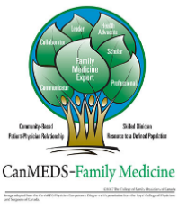  CanMEDS (RCPSC) | CanMEDS-Family Medicine (CFPC)
 | Summary | CPD Program may address. . .
Medical Expert | The most commonly selected role that CPD program planners identify as being addressed through their needs assessment review. In some ways, this is understandable because both Colleges describe the medical expert role as the one that incorporates all of the other competencies! | Clinical reasoning / decision-making; clinical assessment and management; diagnosis, treatment, follow-up; scope of practice; procedural skills
Communicator | Addresses the physician-patient relationship, patient-centered communication, and communication with family. This includes understanding the patient’s fears, context, socio-economic status, family history, social issues and incorporating this understanding into patient care. | Patient values, patient-centred care, disclosure of harm, maintaining accurate and up-to-date patient records;
Collaborator | Incorporates sharing of knowledge, responsibilities, perspectives, and a willingness to work together to achieve the best outcome. This role refers to relationships with patients and their families, physicians, other health professionals, and community partners and may extend to administrative roles, education, advocacy and scholarship. | Teamwork, IPE, handover, referrals, conflict management
Leader | Refers to a physician role in the health care system, their responsibility to provide excellent patient care though their role as a clinician, administrator, educator or scholar. | Leading change, career development, QI, managing practice, health care systems
Health Advocate | Extends beyond the advocacy for a particular patient’s needs. It also reflects the physician’s societal role in prevention, health promotion and equity, in navigating the healthcare system. | Health promotion, equity, community engagement
Scholar | Refers to a physician’s commitment to continuous learning, teaching, evaluation of evidence, and contributing to the creation and sharing of knowledge through research. | Writing, grants, QI, research ethics, research skills, giving / receiving feedback, teaching
Professional | The role of professional refers to a physician’s commitment to ethical practice, high personal standards of behavior, accountability to the profession and society, and maintenance of personal health. | Ethical practice, wellness, personal behaviour, burnout, boundaries

