APPLICATION INSTRUCTIONS FOR JOINT AND STIPENDIARY FACULTY PROMOTION IN THE MEDICAL OR HUMAN SCIENCES DIVISION

Dear Applicant:
Please send your application letter for promotion including the following materials to the address listed below. The complete application will all supporting documents for promotion shall reach the Division Head no later than September 30th for decision in that academic year. The promotion, if granted, will take effect on July 1st, the first day of the new academic year.
The following information must be attached to the promotion application:
- An updated curriculum vitae
- A detailed contributions/teaching dossier, outlining the academic teaching or academic administrative services made to NOSM in the past five years.
- A copy of the research and creative works that you wish to have considered in the examination of the application.

For promotion to Professor only: External Referee’s References form (enclosed):

The names and contact information of four external referees, at least two of whom, are from outside Lakehead and Laurentian Universities, qualified to assess the research and creative works of which two will be chosen by the Division Head. An additional two external referees shall be chosen by the Division Head after consultation with members of the applicant's Division. The Division Head will forward the candidates application to the external referees and request a written opinion.

Notice of Collection

The Northern Ontario School of Medicine (NOSM collects personal information for the purpose of faculty and program evaluation at NOSM including faculty appointment, renewal, promotion, committee work, and program improvement etc. In addition, information may be shared with Lakehead University and Laurentian University as required to administer learner programs. We always respect your privacy, and your information will be protected in accordance with the Freedom of information and Protection of Privacy Act. Direct any questions regarding this collection to the Planning and Risk Director, Grace Vita at (807) 766.7396, 955 Oliver Road, Thunder Bay, Ontario, or gvita@nosm.ca
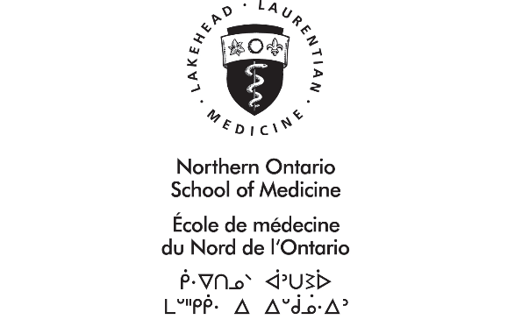

EXTERNAL REFEREES REFERENCE FORM

If you are applying for the rank of Professor, please list the names of four external referees. An external referee must have expertise to enable a critical evaluation of the applicant and be at arm’s length with respect to the applicant. The external referee cannot be a NOSM faculty member; a member of the Joint and Stipendiary Faculty Promotions Committee (JSFPC), the applicant’s Masters, Ph.D., or postdoctoral supervisor; or a research collaborator. The Division Head will forward a copy of the applicable policy, the applicant’s application, all required documentation and request a written opinion.

- Name: Click or tap here to enter text.
Relation to you: Click or tap here to enter text.
Mailing Address: Click or tap here to enter text.
Phone Number: Click or tap here to enter text.
Email Address: Click or tap here to enter text.

- Name: Click or tap here to enter text.
Relation to you: Click or tap here to enter text.
Mailing Address: Click or tap here to enter text.
Phone Number: Click or tap here to enter text.
Email Address: Click or tap here to enter text.

- Name: Click or tap here to enter text.
Relation to you: Click or tap here to enter text.
Mailing Address: Click or tap here to enter text.
Phone Number: Click or tap here to enter text.
Email Address: Click or tap here to enter text.

- Name: Click or tap here to enter text.
Relation to you: Click or tap here to enter text.
Mailing Address: Click or tap here to enter text.
Phone Number: Click or tap here to enter text.
Email Address: Click or tap here to enter text.

Applications, electronic or hardcopy, must be forwarded to the appropriate Division Head and submitted to:

Northern Ontario School of Medicine
Attention: Medical/Human Sciences Division
935 Ramsey Lake Road, Sudbury, ON, P3E2C6

Fax: 705-675-4858
Email: Pamela Lemieux, Medical Sciences Division plemieux@nosm.ca
Kirsten Hysert, Human Sciences Division khysert@nosm.ca

