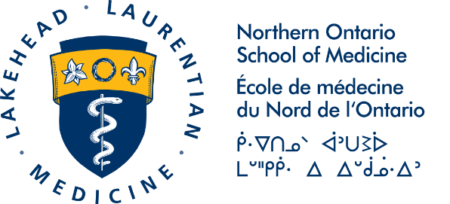

ROGER STRASSER NHRC STUDENT TRAVEL AWARD APPLICATION

This completed application form and a copy of your approved NHRC Abstract must be submitted electronically to the Research Office at research@nosm.ca by August 2, 2019.

Student Applicant Information
Name:  Email: | Academic Level:  ☐ Graduate Student  ☐ Undergraduate Student  ☐ Postgraduate Resident  Academic Department:
Explain why attending NHRC is important to your education, career or professional development (200 words max):

NHRC Abstract Information
Approved Abstract Title:

First Author on Abstract:

List of all Authors on Abstract:

Name and email of Faculty Supervisor:

Appropriate Ethics Approval has been granted for this project?
☐ Yes ☐ No

Description of Research Topic: (relevance or impact of the work you are doing, does it relate to social accountability or rural/remote themes)

Financial Need
Are you receiving funding from other sources to attend NHRC?
☐ Yes
☐ No
Have you previously received a Roger Strasser NHRC Student Travel Award?
☐ Yes
☐ No
What city will you be travelling to NHRC from?

ANTICIPATED BUDGET | AMOUNT
Airfare:
Other transportation method:
List method:
Hotel:
Meals:
Registration:
Other:
List other:
Total Budget:

The following documents are being submitted to research@nosm.ca:

☐ The completed and signed Application Form
☐ A copy of my approved NHRC Abstract

Signatures:

Signature of Student Applicant: _____________________________ Date: __________________________
The signature of the Applicant indicates confirmation of information submitted above.

Signature of Faculty Supervisor: ______________________________Date:__________________________
Signature of Faculty Supervisor acknowledges the research activity described.

